Faculty Profile
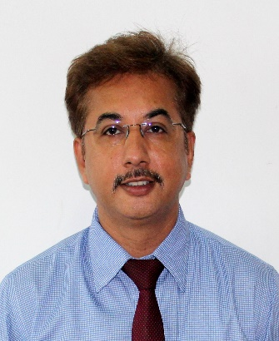

Dr. Yogesh C. Rotliwala, doctorate in chemical engineering (SVNIT, Surat), presently working as a Principal at Gujarat Technological University, Ahmedabad affiliated Pacific School of Engineering, Surat. He has total 25 years of experience including industrial, teaching and research. His major research focuses are in the area of bio-fuel, nanoemulsion, waste water treatment and solid waste management. More than 25 publications, research grant of costing 50 lakh including travel grant from DST for USA and 2 Indian patents are credited to his profile. He has bagged a national award from various prestigious organizations such as Ministry of Chemicals and fertilizers, ISTE, GTU, IIChE. In the field of environmental pollution control, he has successfully completed various consultancy projects for the State Pollution Control Board.

